
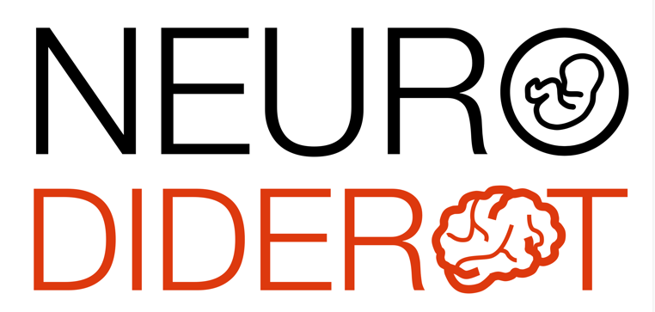

Scientific conference - Robert Debré

Dr Clément Apelian (PhD)

Laboratoire PRHySME (Precison Research in Hypnotism for the Strategy Modulation of Experience) – Paris

Hypnosis beyond fantasy - basic science challenges and clinical relevance

Hypnosis suffers from a controversial public image that simultaneously fuels unreasonable expectations regarding its potential and an a priori skepticism about its very existence. This presentation aims at reviewing the main findings established over more than a century of experimental research on hypnosis, before highlighting the current developments proposed by our team.
The first part will address the longstanding challenge of defining hypnosis, the most robustly established findings, and the main theoretical approaches that seek to provide them with a mechanistic foundation. We will flag a critical limitation common to these theories: the assumption that a single common cause underlies the heterogeneity of hypnotic phenomena. Addressing this issue constitutes the core of our research program, which is articulated around interaction loops between inference and reinforcement mechanisms. We will illustrate this approach through two ongoing projects focusing respectively on the sense of agency (i.e., the feeling of being the author of one’s actions) and on peripheral thermoregulation.

Thursday, February 19, 2026, 11:00 AM
Meeting room, 6th floor of the Bingen building
and video conference via Zoom
https://u-paris.zoom.us/j/84730677369?pwd=AFdhdI6alNWLbXub7sM1DJ33yUIOYN.1

