
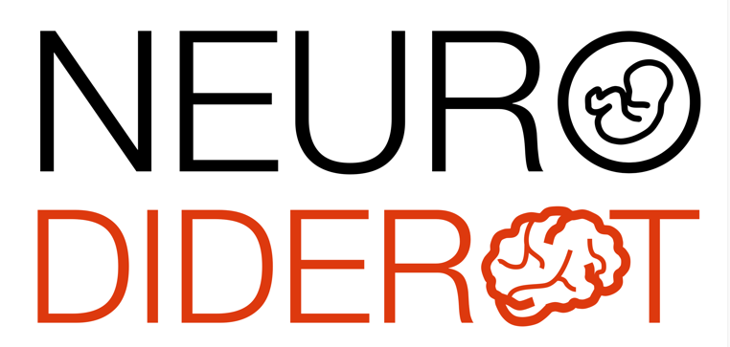

Scientific conference - Robert Debré

Raul Chavez-Valdez, MD

Neonatology - Johns Hopkins University - School of Medicine, Baltimore, USA

Synaptic Plasticity following Neonatal Hypoxic-Ischemic Brain Injury

Aims:
1.Define the critical periods of post-natal brain development
2.Describe the effects of HI in these critical periods of network development in the hippocampus and the modulation by TH
3.Postulate potential outcomes of the derangements produced by HI and not treated by cooling and therapeutic opportunities.

Summary: Intact GABAergic development is a key trigger for the initiation of multiple regionally specific critical periods of synaptic plasticity during the postnatal brain development. These postnatal critical periods occur in succession and staggered from the sensory cortex to the limbic system. The hippocampus critical period of postnatal synaptic plasticity evolves in multiple waves. Neonatal hypoxic-ischemic (HI) brain injury results in disruption of many of the main events governing the progression of the hippocampal critical period of synaptic plasticity, which we have described in detail by our lab. This understanding allows the design of temporally precise treatment strategies to prevent memory impairments, which persist after neonatal HI despite cooling.

Thursday, February 12 2026, 2PM
video conference via ZOOM
https://u-paris.zoom.us/j/84730677369?pwd=AFdhdI6alNWLbXub7sM1DJ33yUIOYN.1

