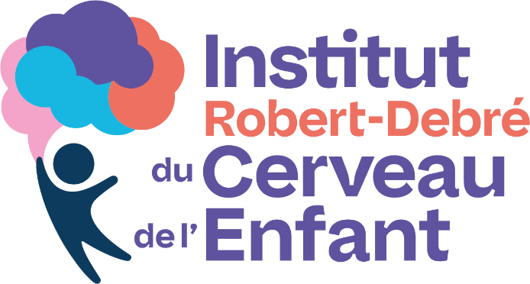
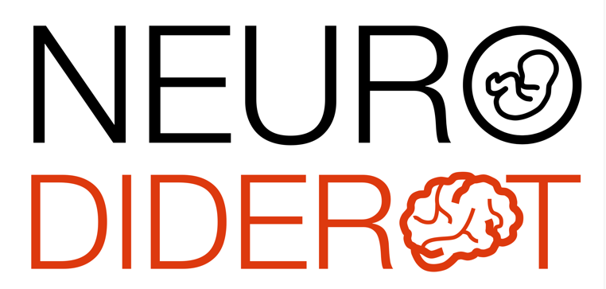

Scientific conference - Robert Debré

Dr Xavier Leinekugel (PhD)

Institut de Biologie de la Méditérannée (INMED), Marseille
Team « Activité précoce dans le cerveau en développement »

Potential consequences of altered maturation of hippocampal perisomatic inhibition on cognitive development and neurodevelopmental disorders

A controversial hypothesis suggests that neurodevelopmental disorders of the autism spectrum may be associated with abnormal maturation of inhibitory circuits in the hippocampus. Using an original approach to assess inhibitory function in vivo, we observed parallel maturation of perisomatic inhibition and activity patterns that could underlie the association between alterations in GABAergic circuits and cognitive development.
In addition to cognitive alterations, neurodevelopmental disorders are strongly associated with emotional disorders that are poorly addressed by conventional behavioral tests. We have developed a behavioral phenotyping tool consisting of an open field platform based on highly sensitive force sensors that detect the slightest movements of the animal in a completely non-invasive manner (including heartbeats during immobility, the dynamics of the forces of each step during locomotion, tremors or shivers associated with pain or fear, etc.). Using this approach, we detect and quantify behavioral components of interest in laboratory rodents that are inaccessible to existing systems.

Thursday, January 22, 2026, 11:00 AM
Meeting room, 6th floor of the Bingen building
and video conference via Zoom
https://u-paris.zoom.us/j/84730677369?pwd=AFdhdI6alNWLbXub7sM1DJ33yUIOYN.1

