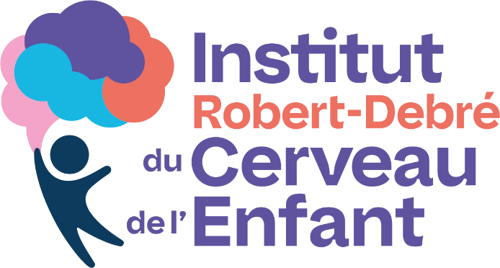
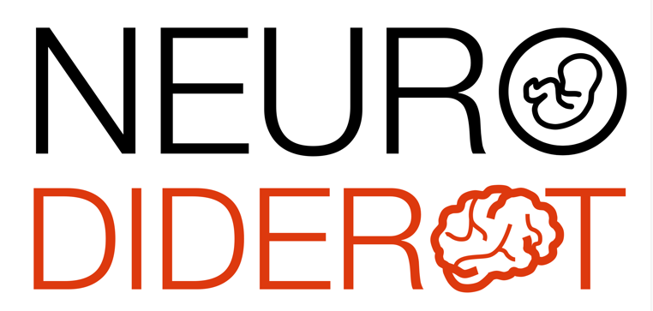

Scientific conference

Dr Danielle Beckman, PhD
California National Research Center, UC Davis

SARS-CoV-2 infects neurons and induces neuroinflammation in a non-human primate model of COVID-19

COVID-19 can induce a plethora of neurological complications in some patients. However, it is still under debate whether SARS-CoV-2 directly infects the brain or whether CNS sequelae result from systemic inflammatory responses triggered in the periphery. In a joint effort at the California National Primate Research Center, we developed a model of COVID-19 in young and aged non-human primates, characterized by substantial neuropathology within days after infection. In this talk, we will discuss how the application of high-resolution microscopy has been helpful in quantifying SARS-CoV-2 pathology across various regions of the olfactory cortex and interconnected brain areas. We will also cover how viral presence and robust neuroinflammatory response were worsened in aged animals, particularly in the presence of comorbidities such as diabetes. Our study provides an initial framework for identifying the molecular and cellular mechanisms underlying SARS-CoV-2 neurological complications, which will be crucial in reducing both the short-term and long-term burden of COVID-19.

Friday, November 28, 2025, 11:00 AM
Meeting room, 6th floor of the Bingen building
and video conference via Zoom
https://u-paris.zoom.us/j/84730677369?pwd=AFdhdI6alNWLbXub7sM1DJ33yUIOYN.1

