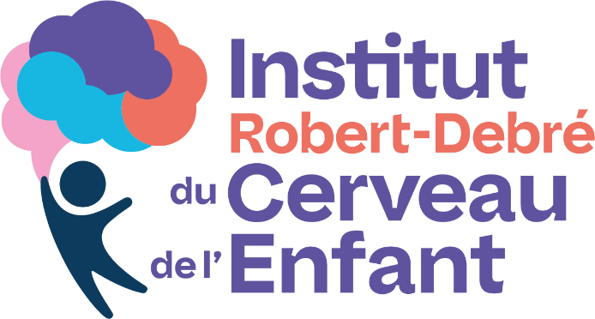
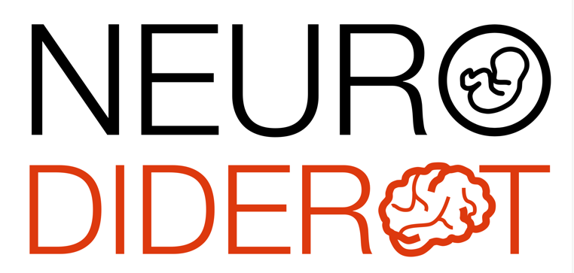

Séminaires scientifiques de Robert Debré

Dr Alexandra Benchoua, PhD
Institut des Cellules Souches pour le Traitement et l'Étude des Maladies Monogéniques - I-Stem

Modèles de cellules souches pluripotentes humaines pour le criblage à haut débit de molécules thérapeutiques et la médecine de précision dans les TND

The unavailability of live patient neurons for research has represented a major obstacle in the elucidation of the etiology of neurodevelopmental diseases and the discovery of efficient treatments. Reprogramming somatic cells into induced-embryonic like- pluripotent stem cells (iPSCs) provides unprecedented opportunities in generating human neuronal models of these diseases compatible with extensive in vitro studies. This presentation will consider the potential of human embryonic and induced pluripotent stem cells for modeling neurological disorders of developmental origin and as a cellular platform for preclinical drug discovery and optimization.

Jeudi 27 Novembre 2025, 11h00
Salle de réunion 6ème étage du bâtiment Bingen
et Visio conférence par ZOOM
https://u-paris.zoom.us/j/84730677369?pwd=AFdhdI6alNWLbXub7sM1DJ33yUIOYN.1

