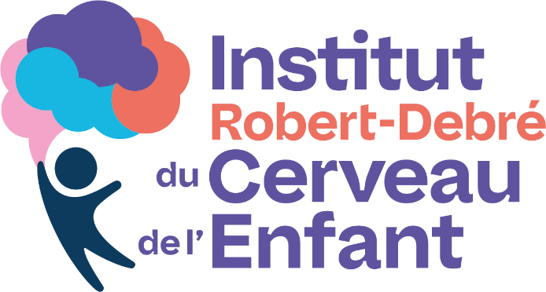
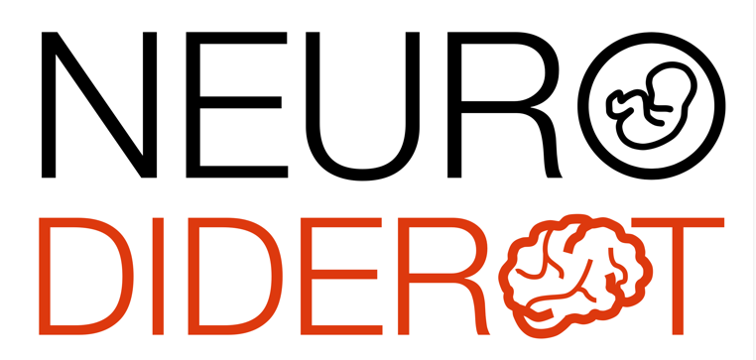

Scientific conference

Dr Alexandra Benchoua, PhD
Institut des Cellules Souches pour le Traitement et l'Étude des Maladies Monogéniques - I-Stem

Human pluripotent stem cell models for high-throughput screening of therapeutic molecules and precision medicine in neurodevelopmental disorders

The unavailability of live patient neurons for research has represented a major obstacle in the elucidation of the etiology of neurodevelopmental diseases and the discovery of efficient treatments. Reprogramming somatic cells into induced-embryonic like- pluripotent stem cells (iPSCs) provides unprecedented opportunities in generating human neuronal models of these diseases compatible with extensive in vitro studies. This presentation will consider the potential of human embryonic and induced pluripotent stem cells for modeling neurological disorders of developmental origin and as a cellular platform for preclinical drug discovery and optimization.

Thursday, November 27, 2025, 11:00 AM
Meeting room, 6th floor of the Bingen building
and video conference via Zoom
https://u-paris.zoom.us/j/84730677369?pwd=AFdhdI6alNWLbXub7sM1DJ33yUIOYN.1

